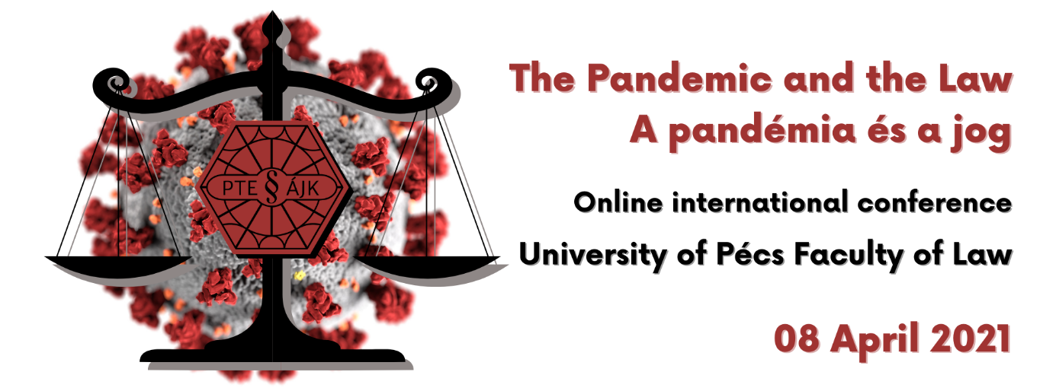

Iris Goldner Lang: 'Laws of Fear' in the EU: The Precautionary Principle and Public Health Restrictions to Free Movement of Persons in the Time of COVID-19
COVID-19 has demonstrated the fragility of EU free movement rules when we are faced with an unknown virus of such magnitude and strength that it threatens our lives, health systems, economies and society. The aim of this presentation is to show the dynamics between the threat of COVID-19 and the rules imposed as a response to the pandemic, which have impacted the functioning of the EU internal market and the Schengen area. The presentation will concentrate on the application of the precautionary principle and public health restrictions, caused by COVID-19, to free movement of persons in the EU. The analysis will lead to three conclusions. First, it will be shown that the decisions to apply free movement restrictions and the logic followed in the EU COVID-19-related documents can be viewed as a triumph of the precautionary principle. Second, it will be argued that implementing the precautionary principle has a transformative effect on the application of the principle of proportionality in EU law. Finally, it will be shown that COVID-19 has emphasised and increased the difference between the conditions for the applicability of public health restrictions when compared to restrictions based on public policy and public security grounds.

Marcin Górski: The Pandemic-related Restrictions on Freedom of Expression
The pandemic caused different types of restrictions regarding freedom of expression. On one hand some states and private individuals (owners of social media platforms) imposed or at least considered imposing restrictions on expressions constituting fake news on the pandemic, its causes, consequences and states’ reactions (one can mention e.g. the famous Twitter’s bans imposed on Mr. D. Trump, former US President). On the other hand the pandemic impaired the public debate: states’ restrictions on public gatherings or the operation of theatres and cinemas resulted in limiting public access to different types of expression as a side effect. Finally, the general tendency resulting from the pandemic to use digital platforms for different types of expressions (be it political, academic or artistic) also influenced to a certain extend the freedom of expression. The paper will analyse these phenomena and assess the adequacy of the constitutional response to them in the context of protecting freedom of expression.
Stefano MONTALDO (associate professor, University of Turin): The EU internal borders in times of pandemic: any lessons for the future of the Schengen area?
The presentation addresses the COVID-19 as a stress-test for the management of the internal borders of the Schengen area. Following a brief overview of the measures taken by the Member States and by the EU institutions to cope with the COVID outbreak, the analysis focuses on the road ahead and on the possible ways out of the enduring crisis of the internal dimension of the Schengen area. In this framework, the presentation firstly discusses the pending reform of the provisions of Schengen borders code concerning reintroduction of controls at internal borders. Secondly, attention is paid to further possible ways of strengthening the Schengen area, such as existing EU instruments of operational police cross-border cooperation and the complementary role of ordinary police checks within the territory of the Member States.

Elisabeth SÁNDOR-SZALAY: Enforcement of minority rights in times of a pandemic – Hungary 2020
The ‘minority way of life’, the field of minority law is a sensitive seismograph: it is worth paying attention to its signals in due course. It can help to paint a picture of the state of mind of the current society, regardless of extraordinary situations. In times of emergency however, it points out vulnerabilities even more clearly. The effective enforcement of minority rights presupposes the joint application of traditional cultural minority rights and equal treatment. The state of emergency declared in the light of the pandemic resulted in a clear restriction on the exercise of individual and collective nationality rights: it has sharpened and highlighted grievances affecting members and groups of more vulnerable ethnic groups, often in a hopeless situation.

Zsolt BUJTÁR: Central bank issued digital currency – challenges and opportunities in the shadow of the Covid-19 pandemic
The Covid 19 pandemic has accelerated and supported the need for new digital online solutions in many aspects of our life. It is especially true for money matters as well. To be able to distribute subsidies fast for employees and households who are with or without bank accounts, it is necessary to have a digital solution. Due to the waves of the pandemic, the monetary policy tools are used quite thoroughly leaving less and less tools for future intervention on behalf of economic policy in the different countries.
According to Bank of International Settlements’ survey in January of 2021, some 80 % percent of respondent central banks are engaged in Central Bank-Issued Digital Currencies (CBDC) study. Whilst decentralized digital (crypto) assets lack viable regulation, central banks put much energy and effort researching central issued digital payment tools (CBDCs). In 2019, IMF and World Bank already issued a quasi-cryptocurrency in exploration of blockchain technology itself.
In his lecture, the author is looking for answers why it is so important to put a lot of energy into these currencies, which advantages and possible dangers would occur by introducing these currencies parallel to incumbent fiat monies. Besides its technical challenges an introduction of a CBDC would have tremendous effects on monetary system and monetary policies of participating central banks. Among possible changes, one might be the turning back of the clock to an earlier period, to the one-tier banking system from the current two-tier one.
At the same times as an aftermath of global financial crisis, 2007-2008 central banks have been limited their set of tools fighting against deflationary pressures and supporting national economies in arising from recessions. While applying zero interest rate policies and with hundreds of millions of people without access to financial system, it is also inevitable to look for new technologies and solutions in the currency systems.
As a result of Covid-19 pandemic and its economic aftermath, the need for new digital money is even more relevant. After the pandemic, when the world (household and companies) will be more indebted than ever, there would be a great need for an effective and modern monetary and credit policy to support a sustainable growth for our planet Earth.
In this lecture, the author examines legal and economic pros and contras for a possible introduction and probably a swifter introduction of CBDCs.

Elizabeth PLATT: Tracking the legal response to COVID-19 in the United States
Since the arrival of COVID-19 in the United States, federal and state governments have taken varying degrees of legal action to prevent the spread and mitigate its devastating impact on the public’s health and health care systems. Federal action primarily consisted of national emergency declarations, restrictions on foreign nationals entering the country, laws aimed at mitigating the economic impacts of COVID-19 closures, and social distancing guidelines. Most of the direct legal action occurred on the state level, including travel restrictions, stay-at-home orders, mask-wearing requirements, business and school closures, and gathering bans.
This presentation will first provide insight on the legal framework for public health emergencies in the United States at both the federal and state level. Specifically, it will highlight the emergency laws and powers that shape how the United States responds during national emergencies. Secondly, this presentation will detail the legal interventions taken during the pandemic to mitigate the spread of COVID-19 at the state level. This presentation will lastly describe policy surveillance methods, a scientific process used to track these rapidly emerging laws to create legal data for evaluation.

HERKE Csongor: Büntetőeljárás az új koronavírus miatti veszélyhelyzet idején
Az új koronavírus megjelenése, gyors terjedése váratlan kihívások elé állította ez egész világot, köztük hazánkat is. Ez a vírus nemcsak a mindennapi életre jelent komoly veszélyt, hanem a bűnüldözésre is váratlan terheket rótt. A megnehezedett körülmények között mind a nyomozó hatóság, mind az ügyészség, mind a bíróságok olyan nehézségekkel kell, hogy szembenézzenek, amelyek sokszor megoldhatatlan feladat elé állítják őket. A hagyományos módszerek mellett újakat kellett bevezetni, nem is beszélve a személyes jelenlétet igénylő eljárási cselekményekkel kapcsolatos gondokról.

Pánovics Attila: Utolsó figyelmeztetés?
2008-ban jelent meg Végh László, Szám Dorottya és Hetesi Zsolt könyve, „Utolsó kísérlet – Híradás a Föld állapotáról” címmel. Annak az évnek az őszén az USA-ban kirobbant pénzügyi válság rövid időn belül általános gazdasági recesszióhoz vezetett. 12 évvel később újabb, de egészen másfajta krízishelyzettel szembesültünk, melynek hátterében azonban szintén megjelennek az évtizedek óta zajló gazdasági és társadalmi folyamatok káros következményei.
A pandémia okozta veszélyhelyzet lehetőséget ad rá, hogy alaposan átgondoljuk a hosszú távú céljainkat, a modern életmódunkat támogató, legfontosabb termelési és fogyasztási rendszereink fenntarthatóvá tételéhez szükséges lépéseket (élelmiszeripart, mobilitást, energiaipart stb.). Mivel az idő egyre jobban sürget, a jogi eszközöknek kulcsfontosságú szerepet kell játszaniuk a fájdalmas, de immár elengedhetetlen döntések meghozatalában.

Pfeffer Zsolt: A világjárvány okozta kihívások a közpénzügyekben
A világjárvány folytán újra kellett gondolni rövid idő alatt a közbevételek és a közkiadások egyes kérdéseit: a költségvetési politika, az adópolitika, a rendkívüli támogatások (könnyítések) és közbeszerzések átmeneti, rendkívüli szabályozása (újragondolása) vált szükségessé a veszélyhelyzet folytán, amely jelentős hatást gyakorolt az államadósságra és az államháztartási hiányra is.

Békési Gábor: A járványhelyzet társadalombiztosítási jogi kérdései
Az előadás áttekinti a járványhelyzetben felmerülő társadalombiztosítási jogi – és azokhoz közvetlenül kapcsolódó munkajogi – kérdéseket. Az előadás a hatályos hazai tételes jogi rendelkezéseket elemzi és értékeli, s rámutat azokra az ellentmondásokra, amelyek a járványhelyzet ún. harmadik hullámában is fennállnak, figyelemmel arra, hogy a 2020. év tavaszán született (és részben már hatálytalan) rendkívüli kormányzati intézkedések napjainkig megoldatlanul hagytak számos a gyakorlat által felvetett problémát.

